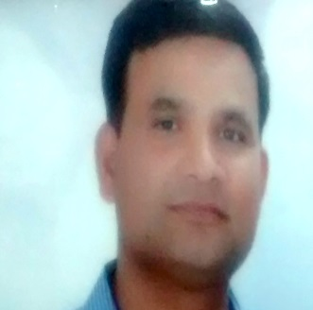 SANTOSH KUMAR MISHRA
Mobile: 07520286787,9458076742 ~ E-Mail: mishra.santosh901@gmail.com

SENIOR MIDDLE MANAGEMENT PROFESSIONAL
~ HR Operations ~ General Administration ~
A multi-faceted professional having creative intellect/ insight & sharp planning skills to meet organizational objectives & to secure position in the field of knowledge based Management in a company / institution with considerable advancement opportunities and scope to use my knowledge and skills in the field of Education, Human resource planning & execution, Project management, General administration & technology based management.
PROFILE SUMMARY

A versatile professional with nearly 17+ years of experience in:

HR Operations General Administration Team Management
Technical Correspondence Security & inspection Liaison & Coordination
Vendor Management MIS Documentation Manpower Management

- Skilled in planning human resource requirements in consultation with heads of different functional & operational areas
- Extensive experience in general administrative activities, personnel management, policy implementation and facility operations across assignments
- Demonstrated excellence in overseeing administration of various departments and maintaining coordination between various internal departments for smooth functioning
- A keen communicator with honed interpersonal, problem solving and analytical abilities

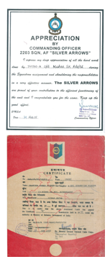
CORE COMPETENCIES

General Administration :( for five yrs)
- Handling overall forecasting, distribution & consumption of resources to meet organizational goal.
- Ascertaining smooth execution of various operations and maintaining proper decorum & discipline through implementation of policies & procedures.
- Overseeing the time office functions, attendance, employee records, codified procedures and leave records.
- Handling venders for smooth operation & supply chain management.
- Oversee works, correspondences which requires HR & technical expertise to handle affairs.

Technical expertise (19 yrs with administrative activities)

  - Experience of handling ground communication system & their maintenance.
  - Operation & maintenance of Aviation/ transport Aircraft in IAF.
  - Authorize to carry out II& III line servicing on Aircraft system.

ORGANISATIONAL EXPERIENCE
Mar 1996 to Jun 2015 Indian Air Force as Senior non- commissioned officer – Communication, HR & Administration Departments

Key Result Areas:
- Involved in various development, works & logistics plan and ensuring their implementation
- Managing the official records & files related with general and technical correspondence
- Functioning as coordinator between higher & lower management
- Monitoring the personnel and ensuring discipline & etiquette in them
- Accountable for maintenance of official files & documents
- Carrying out detailing of personnel for various duties, courses & training
- Developing & maintaining all documents pertaining to aircraft & office

Highlight:
- Recognized with several prizes in various competition

TRAININGS

- Undergone training in the following:
- Diploma in Electronics and Telecommunication System from communication training institute, Bengaluru by IAF.
- Maintenance and Conversion Flight AVRO HS-748 Transport Aircraft from Navigation Training school, Begum pet, Hyderabad.
- Quick Reaction Team Supervision and Management at Air force station, Coimbatore by IAF

PROFESSIONAL ENHANCEMENTS

- Completed MBA Project on Customer Satisfaction in Private & Public Sector Banks in Coimbatore.
- Carried out:
- M.Phil. research work on Temple Architecture of Dev Surya Temple, Aurangabad, Bihar.

EDUCATION

2008 M.Phil. (History) from Annamalai University, Chidambaram
2011 MBA (Information System) from Bharathiar University, Coimbatore
2004 MA (History) from Kurukshetra University, Kurukshetra
2001 BA (History) from IGNOU

EXTRACURRICULAR ACTIVITIES

- Served NCC for 2 years with ‘A’ certificate
- Participated in Scouts and Guide for 3 years

PERSONAL DETAILS

Name : Santosh Kumar Mishra
Father’s Name : Sri Ghanshyam Mishra
Date of Birth & Age : 29 Sep 1977, 39 yrs
Nationality : Indian, Hindu
Marital Status : Married
Linguistic Abilities : English & Hindi (Read, write and speak)
Address: House No. - 48, Vimal City, Shamshabad Road, Near TV Tower, Rajrai Agra 282001

DECLERATION

I here by declare that above said information furnished by me are true and correct to the best of my knowledge

Place: Agra

Signature
Date: 15 Jan 17 (Sk mishra)

