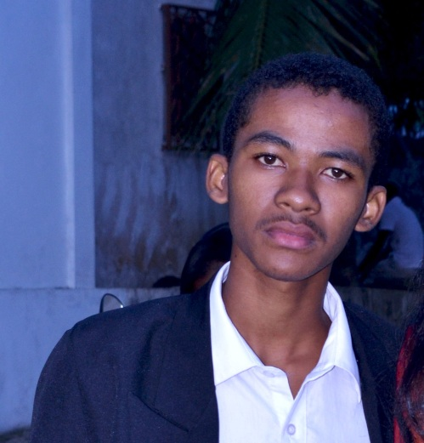
ANDRIANAIVO Andriniaina Fredo
Tananarive, Madagascar
Lot VT 85 XAJ, Andohanimandroseza
Number phone: +261342846310 / +261327138074
andriniainafredo@gmail.com / fredoandrianaivo@yahoo.fr
Website: http://fredoandrianaivo.com/
Born the 25 January 1997 at Toamasina
Web Developer and Software
2 years of experience in computer development, web sector and software engineering.
Studies and degrees
2011 – 2012 : BAC
2013 – 2015 : DTS
2015 – 2016 : License
2016 – 2017 : Master I
Trainings followed
June 2014 : APP Challenge with Orange operator
Mach 2015 : Object Oriented Programming (OOP).
December 2016 : OpenDays – Training in Java DSL Server.
Professional experience
January 2014 -> May 2014 : Trainee at the company SPAT (Port Company at Autonomous Management of Toamasina). My mission is to create software that manages employee supply requests.
April 2016 -> June 2016 : Development of a website that managed student recordings, schooling, course distribution... for a school EGM (School Music and Guitar) which I have already studied before.

September 2016 -> October 2016 : I did the integration of a website (WordPress) for a friend (dick training).
February 2016 -> June 2017 : Master Thesis Project I, the objective was to realize a system of telephone geolocation (Android). I created a site that served as a server and an Android application that worked as a plotter in the phone to geo-located.
June 2017 -> August 2017 : Realization of my own personal website.

Skills domains
More concretely I am specialized in the development of website seen that it is my biggest passion in parenthesis, on the other hand I also have some experience in the programming of a software in particular on the management of stock. The languages I have the skills are:
For the Web :
- HTML&CSS (Bootstrap, Foundation…)
- JavaScript (AJAX, JQuery, NodeJS, …)
- PHP (POO, MVC, CakePHP)
- And other Framework like FullCalendar JS ou Cropper…
For the software
- Java (Swing, awt, FX), Java Socket, JSP…
- VB.Net
- C#
- And Android
About the design
- Adobe Photoshop et Illustrator
I also have a good experience on audiovisual and many other things besides computer development.
Language
Malgache : Natale
Français : Fluently
Anglais : School
Entertainment
Attended cybercafés
Playing basketball
Play piano
Play soccer
Reading
Have fun with friends

