Changes Required
- The contact number of the saved profile is getting displayed while searching the profile in the “SEARCH PROFILE” Button. Please see below. Make it as in the case of email id
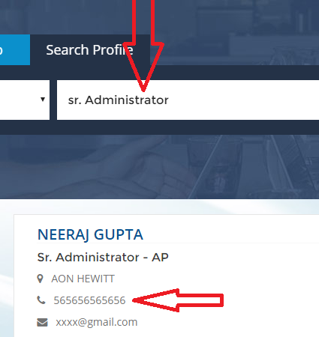
- Also do add “HIRE ME” button as shown below. Keep the texture/color/font style&colour as per the “View Details” button

- Please provide an option to view all under the “featured freelancers” information so as to view all the saved freelancers at one go. See Below :
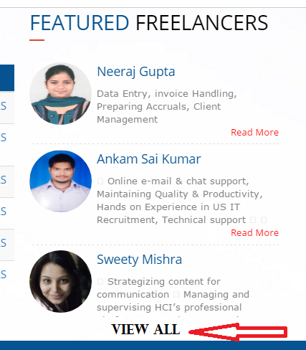

4.

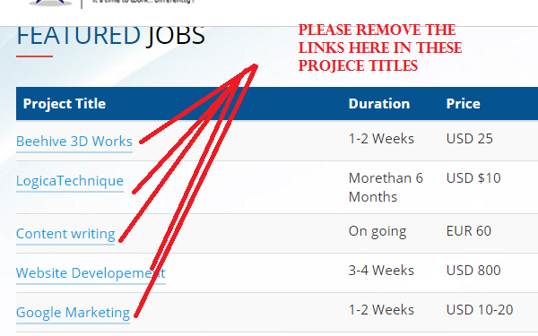

- Do add the title “DESCRIPTION” to represent “DETAILS” Links. See below :

