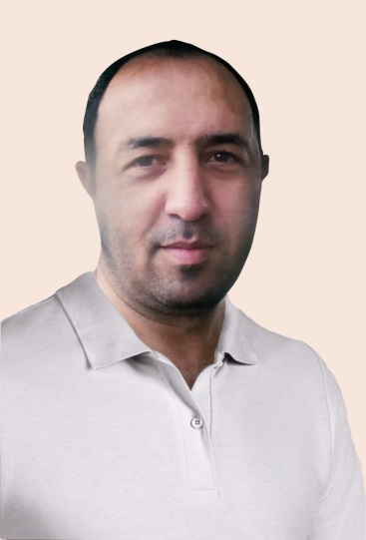
UMIT ARSLAN
Graphic/Print Designer
BANGKOK| THAILAND

Motion, Graphic and

Digital Designer
http://mitarsla8.wixsite.com/resume (pls check my resume online)
Contact: mitarslan@hotmail.com
Tell: 0640207470
PERSONAL INFORMATION
Sex : Male
Date of Birth : 01/11/1979
Marital Status : Single
Nationality : Turkish
Driving License : B

Sir or Madam,
My name is Umit Arslan. I am from Turkey but I am living in Thailand. I am designer since 2005. I have been in multi type sector about designing. Textile, Print house and web. My new skill is Graphic Motion. You can see some sample about my skill in page. I don’t have travel problem. I can move local of job.​
GRAPHIC EXPERIENCE
10/2005 – 01/2007 Turkey Army troops school print house
Get ready book and brochure, make graphic and arrange pages, edit pages of book. Make poster and digital art designs

06/2007 - 12/2016 Gunkar A.S. Co. sunset swimwear http://www.sunset.tc/ http://www.gunkar.com.tr/ Istanbul/Turkey
Graphic designer for web and for digital print.
Designer prepare visual effect for web page and prepare graphic for advertisement. Creative design for garments

- 2017 Freelance Graphic Motion Artist (Thailand)
Pls check below links for visual samples of my skills
http://freedesign-freedesign.blogspot.com/
https://www.shutterstock.com/g/esparanza
https://www.youtube.com/user/mitarslan1/videos?view=0&sort=dd&shelf_id=0

OBJECTIVE
To pursue a career in design where my detail orientation and analytical skills would be an asset.

EDUCATION
University Suleyman Demirel University – Isparta / Turkey
Fine Arts – 09/2000 – 06/2004

ADDITIONAL EDUCATION & CERTIFICATES
01/01/2005 International trade and marketing / Istanbul University
3 month training on International trade and marketing

COMPUTER SKILLS
Word, Excel, Powerpoint, Outlook: Excellent
Corel Draw, Adope Photoshop, Adobe illustrator , After Effect: Excellent
Adobe Flash, Cinema 4D: Good

LANGUAGE SKILLS
English Reading: Advanced, Writing: Advanced, Speaking: Good
Trukish Reading: Good, Writing: Good, Speaking: Good

SOCIAL ACTIVITIES
Photography, Travel, social media

CLUB & ASSOCIATION MEMBERSHIPS
Marmara University Alumni, Beşiktaş High School Alumni

